# NAME- ABHISHEK SAHIB; UID-23BCC70063; SUB- ADBMS

**EXP-11**

* **AIM:** To demonstrate how **row-level locking and transactions** can prevent duplicate enrollments and preserve **data consistency** when multiple users attempt concurrent operations on the same student record.

# THEORY:

* Transactions in DBMS: Transactions ensure a sequence of operations executes as a single unit, maintaining Atomicity, Consistency, Isolation, and Durability (ACID).
* Concurrency Problems: Without proper locking, two users could insert or update the same student record simultaneously, causing duplicate enrolments or inconsistent data.
* Unique Constraints:Define (student_name, course_id) as UNIQUE to prevent duplicate enrollments.
* Row-Level Locking with SELECT FOR UPDATE:Locks specific rows during a transaction, blocking other users from updating the same rows until the transaction is committed or rolled back.
* Prevents race conditions in concurrent environments.
* Locking Preserves Consistency:Ensures no duplicate enrollments occur.
* Conflicting operations are serialized automatically.

# CODES:

* Part A: Prevent Duplicate Enrollments Using Unique Constraint
* ​
  + -- Drop table if exists

DROP TABLE IF EXISTS StudentEnrollments;

-- Create table with unique constraint CREATE TABLE StudentEnrollments (

enrollment_id INT PRIMARY KEY, student_name VARCHAR(100) NOT NULL, course_id VARCHAR(10) NOT NULL, enrollment_date DATE NOT NULL, UNIQUE(student_name, course_id)

);

-- Begin transaction to insert multiple records START TRANSACTION;

INSERT INTO StudentEnrollments (enrollment_id, student_name, course_id, enrollment_date)

VALUES

(1, 'Ashish', 'CSE101', '2024-07-01'),

(2, 'Smaran', 'CSE102', '2024-07-01'),

(3, 'Vaibhav', 'CSE101', '2024-07-01');

COMMIT;

-- Verify inserted records

SELECT * FROM StudentEnrollments;

Part B: Use SELECT FOR UPDATE to Lock a Student Record

-- User A locks a row for Ashish in CSE101 START TRANSACTION;

SELECT * FROM StudentEnrollments

WHERE student_name = 'Ashish' AND course_id = 'CSE101'

FOR UPDATE;

-- At this point, User A keeps transaction open

-- User B attempts to update the same row:

-- UPDATE StudentEnrollments SET enrollment_date = '2024-08-01'

-- WHERE student_name = 'Ashish' AND course_id = 'CSE101';

-- User B will be blocked until User A commits or rolls back

-- User A then commits COMMIT;

-- After commit, User B can proceed

* Part C: Demonstrate Locking Preserving Consistency

-- Simulate concurrent updates

-- User A starts transaction START TRANSACTION;

SELECT * FROM StudentEnrollments

WHERE student_name = 'Ashish' AND course_id = 'CSE101'

FOR UPDATE;

-- User A updates enrollment_date UPDATE StudentEnrollments

SET enrollment_date = '2024-07-15'

WHERE student_name = 'Ashish' AND course_id = 'CSE101';

-- User B (simulated concurrently) tries to update same row

-- UPDATE StudentEnrollments SET enrollment_date = '2024-08-01'

-- WHERE student_name = 'Ashish' AND course_id = 'CSE101';

-- This will be blocked until User A commits

-- User A commits COMMIT;

-- Verify final state

SELECT * FROM StudentEnrollments;

# OUTPUTS:

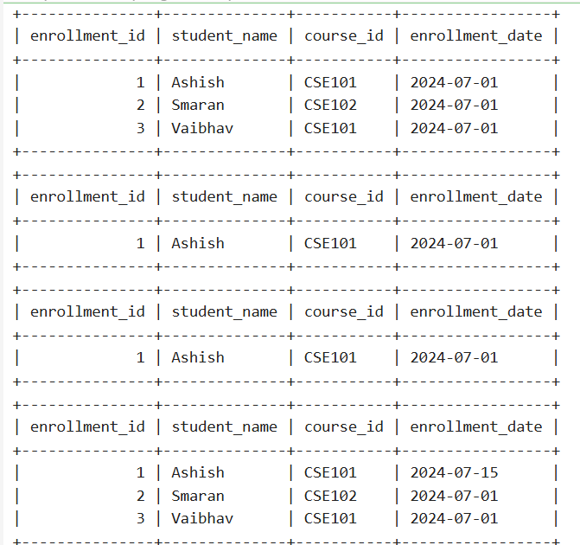

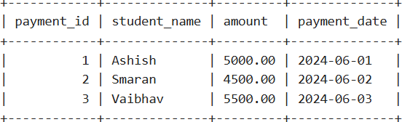

* **LEARNING OUTCOMES:**

1. Learned to enforce unique constraints to prevent duplicate student enrollments.
2. Understood row-level locking using SELECT FOR UPDATE to handle concurrent transactions.
3. Observed how transactions preserve Atomicity and Consistency in a multi-user environment.
4. Practiced handling blocked transactions and understanding isolation effects.
5. Gained hands-on experience with ACID principles in a practical enrollment scenario.